**SMART WATER MANAGEMENT**

**During the past decade, water needs have increased unpredictably in India. Increasing demand of water supply has become a major challenge for the world. Wasteful usage of water, climatic changes and Urbanization has further depleted the resource. Conservation and management of the resource must be given utmost importance. In this paper, we present an IoT design for water monitoring and control approach which supports internet based data collection on real time bases. The system addresses new challenges in the water sector -flow rate measuring and the need for a study of the supply of water in order to curb water wastage and encourage its conservation. We also measure the quality of water distributed to every household by deploying pH and conductivity sensors. The traditional water metering systems require periodic human intervention for maintenance making it inconvenient and often least effective.For shortcoming of the existing models for a ubiquitous usage of wireless systems for smart quality monitoring and communicate data wireless**



Smart Water Management datasets

**.Smart Water Management System (Intel-Io T)**:

This project aims to manage water supply throughout the scale, right from small societies, townships to entire urban infrastructure and also for irrigation water supply management. It involves the use of IoT to take into account water wastage right from our homes to the large scale. [The system can control the water usage in a precise way and can also be used for remotely controlling the water flow, cutting the water supply, monitoring and analyzing the water usage across the nodes, with the help of an android app and cloud connectivity](https://www.instructables.com/Smart-Water-Management-System/" \t "_blank)[1](https://www.instructables.com/Smart-Water-Management-System/" \t "_blank).

**.Water Management & Water Conservation Methods**:

This resource provides a few water conservation methods that can be practiced by individuals to reduce the wastage of water. [Some of these methods include installing flow-restricting shower heads to save water during showers, taking bucket-baths instead of showers, turning off the tap while shaving or brushing teeth, and immediately fixing any leaking taps and pipes in our homes](https://byjus.com/chemistry/water-management/" \t "_blank)[2](https://byjus.com/chemistry/water-management/" \t "_blank).

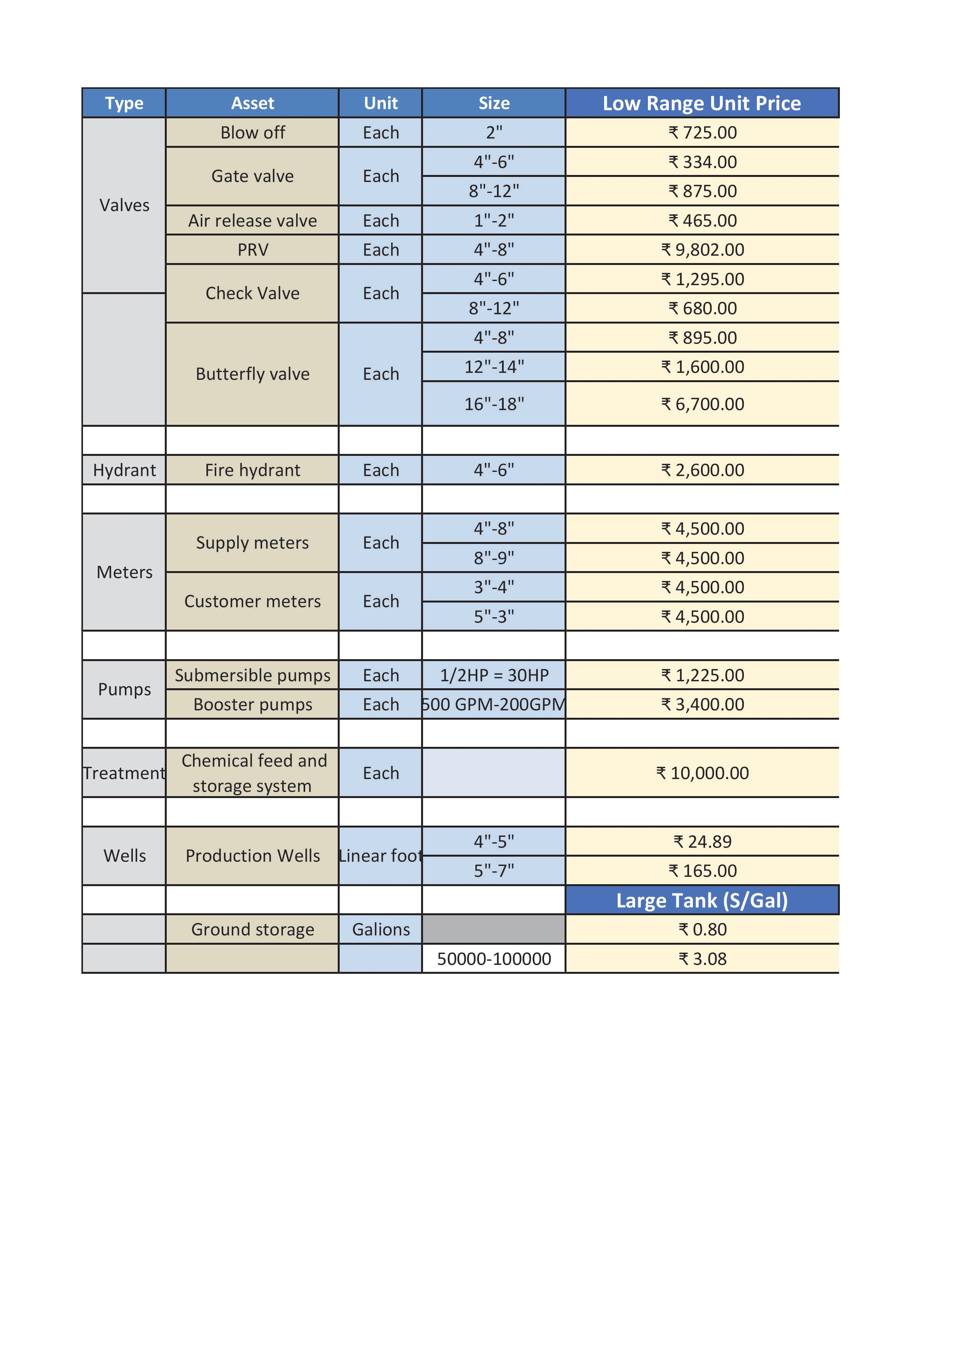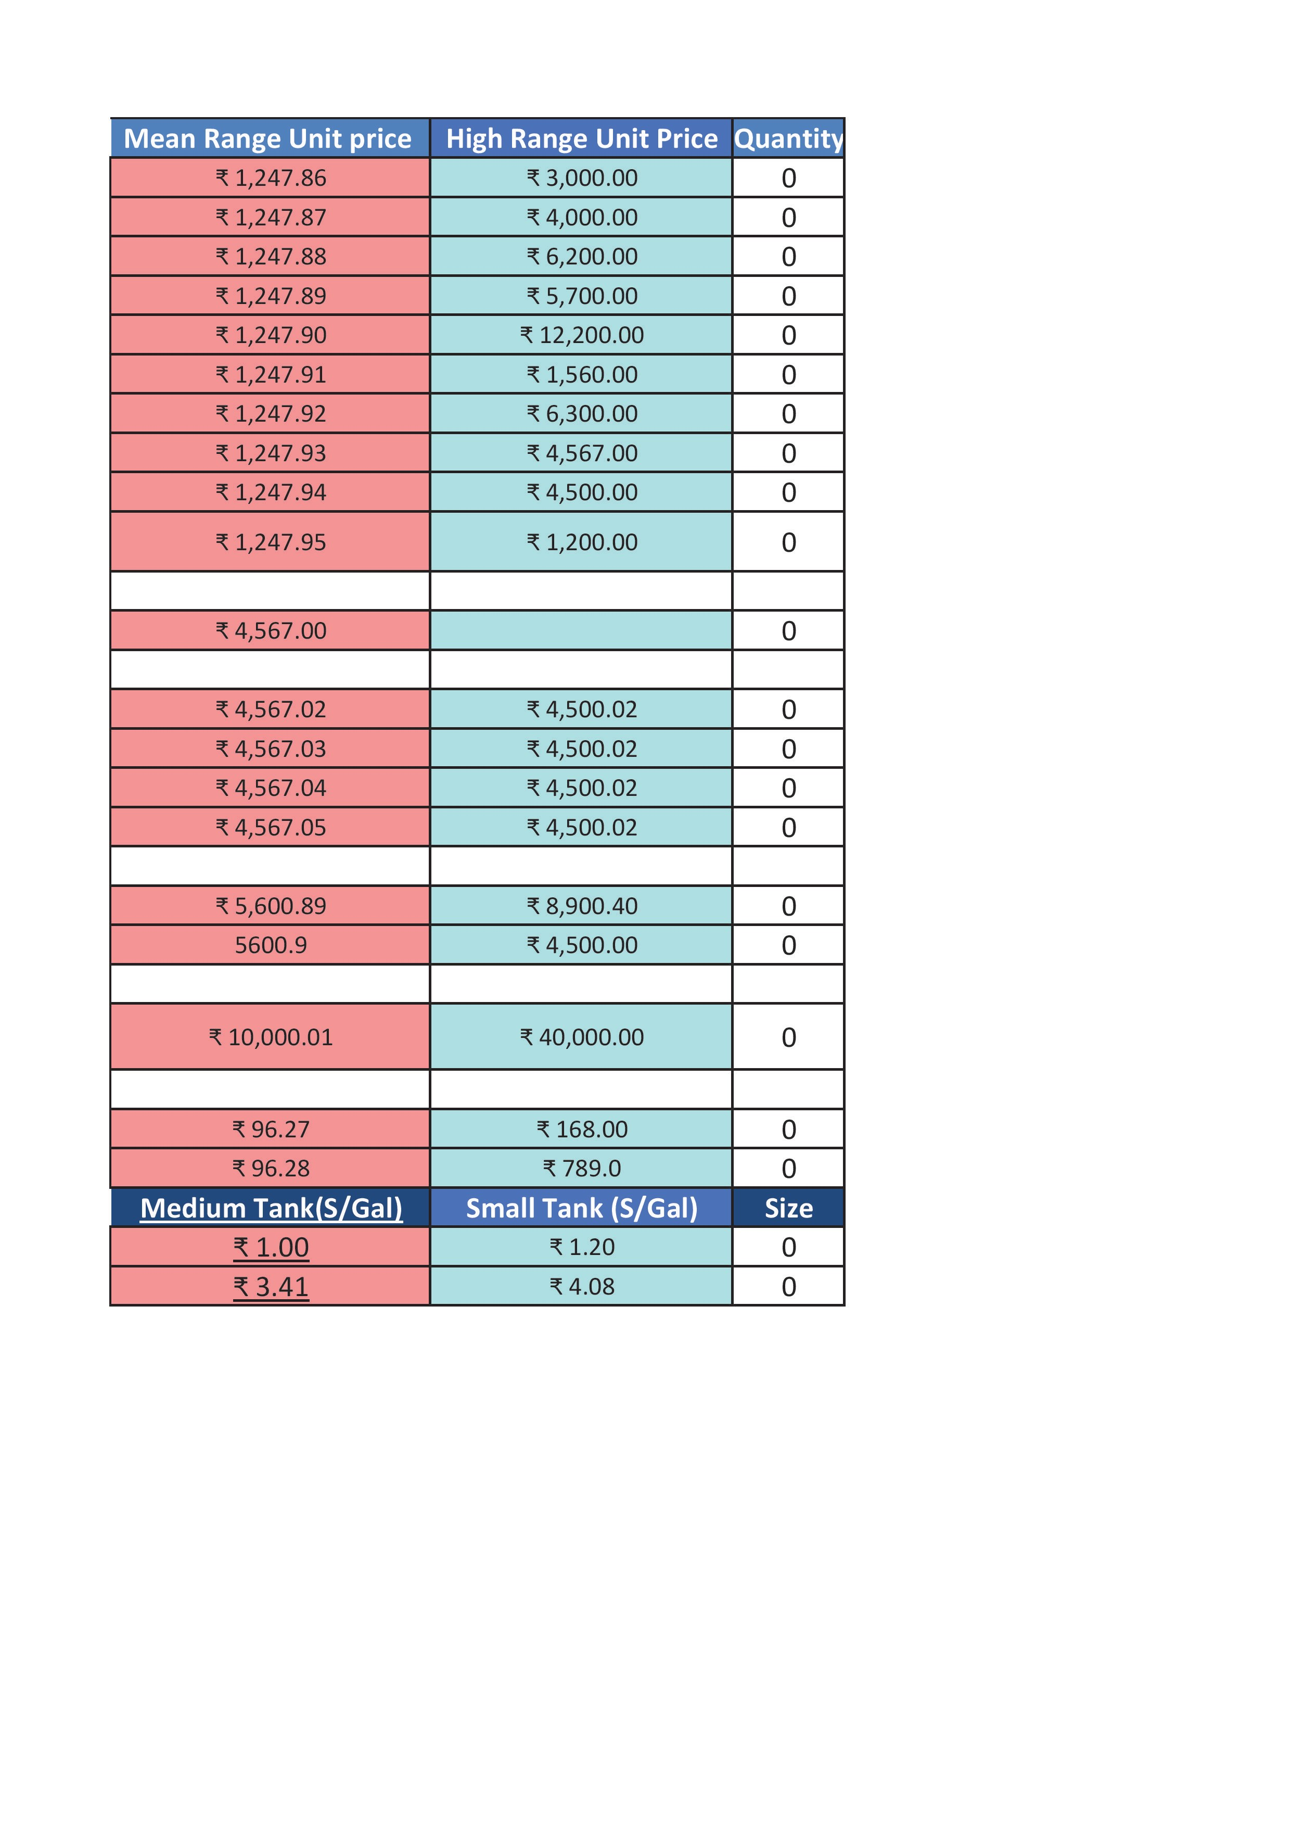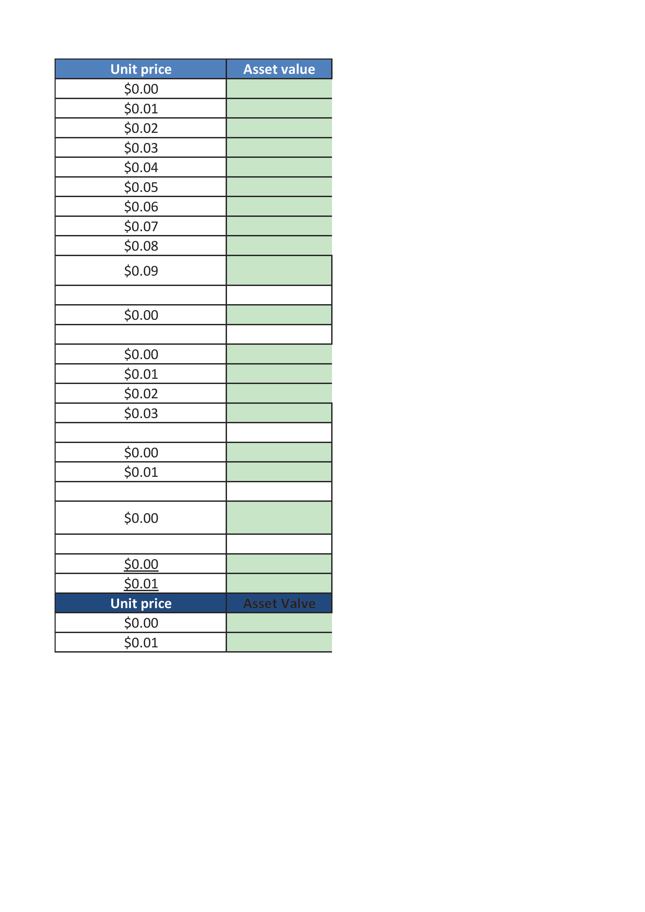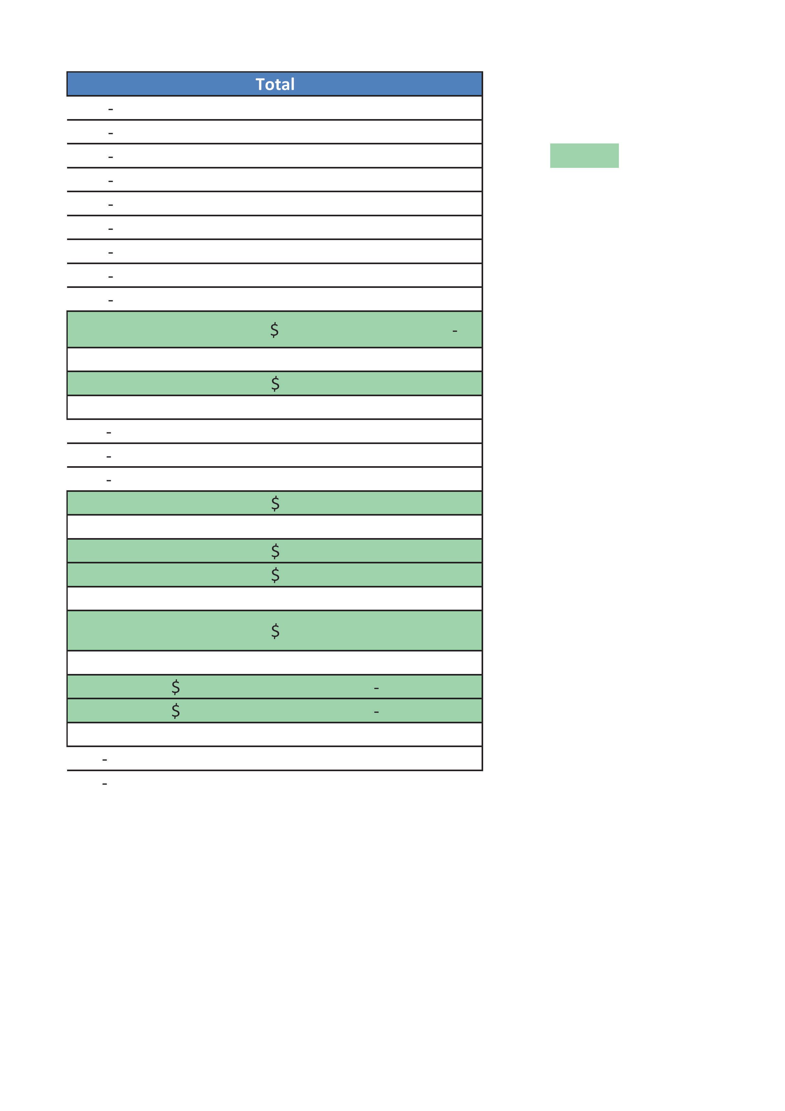

*smart water management program cording*

program( python coding):

import machine

import time

TRIGGER\_PIN = 23

ECHO\_PIN = 22

LEAK\_LED\_PIN = 19

trigger = machine.Pin(TRIGGER\_PIN, machine.Pin.OUT)

echo = machine.Pin(ECHO\_PIN, machine.Pin.IN)

leak\_led = machine.Pin(LEAK\_LED\_PIN, machine.Pin.OUT)

def measure\_distance():

trigger.value(0)

time.sleep\_us(5)

trigger.value(1)

time.sleep\_us(10)

trigger.value(0)

pulse\_start = pulse\_end = 0

while echo.value() == 0:

pulse\_start = time.ticks\_us()

while echo.value() == 1:

pulse\_end = time.ticks\_us()

pulse\_duration = pulse\_end - pulse\_start

distance = (pulse\_duration \* 0.0343) / 2

return distance

def check\_for\_leak():

distance = measure\_distance()

threshold\_distance = 10 # Adjust this value based on your tank setup

if distance < threshold\_distance:

return True

else:

return False

while True:

if check\_for\_leak():

leak\_led.value(1)

time.sleep(0.5)

leak\_led.value(0)

time.sleep(0.5)

else:

leak\_led.value(0)

time.sleep(1)

output :

